ADNAN MENDERES UNIVERSITY

CSE204 Computer Networks

Assignment 1 - UDP Pinger

Elif MUSLU

151805046

SOLUTİON

*SERVER CODE:*

*# UDPPingerServer.py***import** random  
**import** socket  
  
server_socket = socket.socket(socket.AF_INET, socket.SOCK_DGRAM)  
server_socket.bind((**'127.0.0.1'**, 12000))  
  
**while True**:  
 rand = random.randint(0, 10)  
 message, address = server_socket.recvfrom(1024)  
 message = message.upper()  
 **if** rand >= 4:  
 server_socket.sendto(message, address)

*CLİENT CODE:*

**from** datetime **import** datetime  
**import** socket  
**import** argparse  
**for** pings **in** range(10):  
 client_socket = socket.socket(socket.AF_INET, socket.SOCK_DGRAM)  
 client_socket.settimeout(1.0)  
 message = **'Relpy from '** addr = (**"159.65.86.119"**, 12000)  
  
 start = datetime.now()  
 client_socket.sendto(message.encode(), addr)  
 **try**:  
 data, server = client_socket.recvfrom(1024)  
 end = datetime.now()  
 elapsed = end - start  
 print(**f'{data.decode()} 159.65.86.119:12000 Ping: {pings} {datetime.now()}'**)  
 **except** socket.timeout:  
 print(**'REQUEST TIMED OUT'**)

*Sending UDP request this 159.65.86.119:12000 ip adress:*

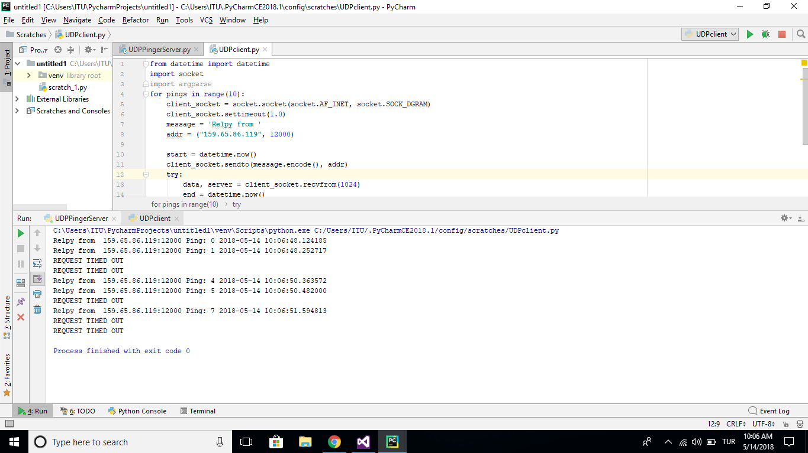

*WİRESHARK*

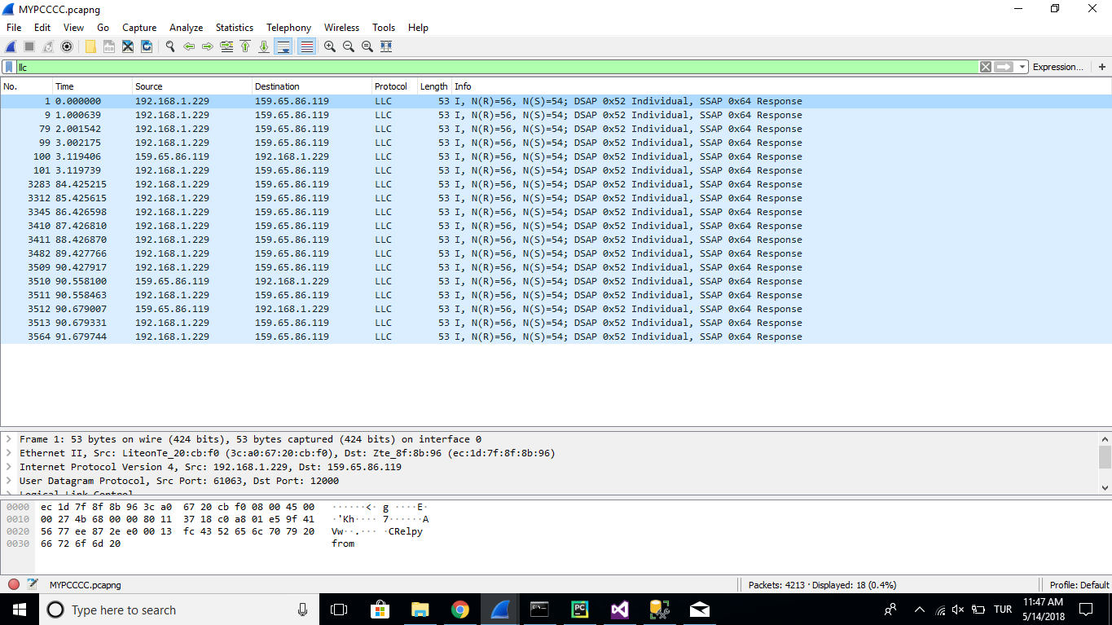

*Sending local machine to another local machine:*

*SERVER CODE:*

**import** random  
**import** socket  
  
server_socket = socket.socket(socket.AF_INET, socket.SOCK_DGRAM)  
server_socket.bind((**'192.168.1.229'**, 12000))  
  
**while True**:  
 rand = random.randint(0, 10)  
 message, address = server_socket.recvfrom(1024)  
 message = message.upper()  
 **if** rand >= 4:  
 server_socket.sendto(message, address)

client code:

**from** datetime **import** datetime  
**import** socket  
**import** argparse  
**for** pings **in** range(10):  
 client_socket = socket.socket(socket.AF_INET, socket.SOCK_DGRAM)  
 client_socket.settimeout(1.0)  
 message = **'Relpy from '** addr = (**"192.168.1.229"**, 12000)  
  
 start = datetime.now()  
 client_socket.sendto(message.encode(), addr)  
 **try**:  
 data, server = client_socket.recvfrom(1024)  
 end = datetime.now()  
 elapsed = end - start  
 print(**f'{data.decode()} 127.0.0.1:12000 Ping: {pings} {datetime.now()}'**)  
 **except** socket.timeout:  
 print(**'REQUEST TIMED OUT'**)

